Lab3 Raspberry pi

Computer Systems Fundamentals, 2016-17 SEM1

Name: Jamie Geddes

Email address: Jamie.geddes@yorksj.ac.uk

**Contents page**

Task1

Task2

Task3

Task4

Task5

Task6

Task7

Task8

**Task 1**

Find out the external devices mounted on your Raspberry Pi and their IDs

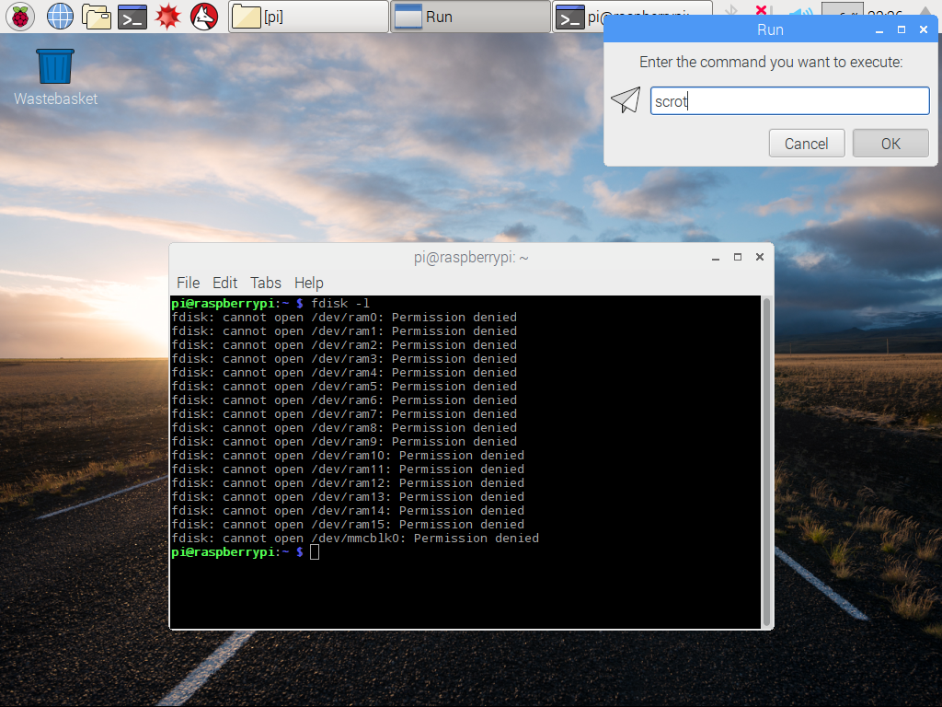

**Task 2**

Create a new user and update the password

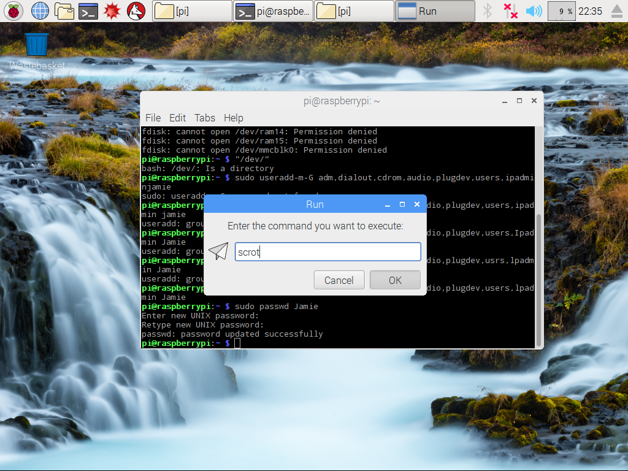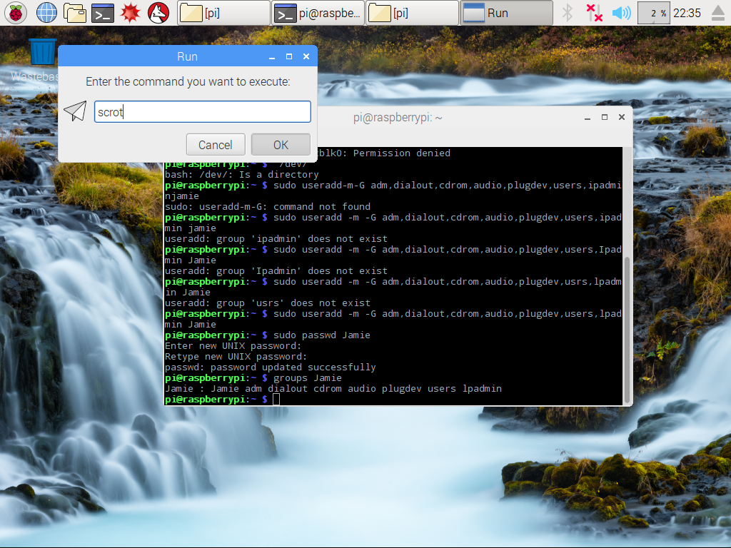

1. Find out what the -m and -g flags mean

../../../../Users/jack.bates-lang/Desktop/Screen%20Shot%202016-11-15%

../../../../Users/jack.bates-lang/Desktop/Screen%20Shot%202016-11-15%

-M= adding new home directory

-G= Add to the following groups

B.

Check what groups the user pi is a member of and which groups the new user is a member of.

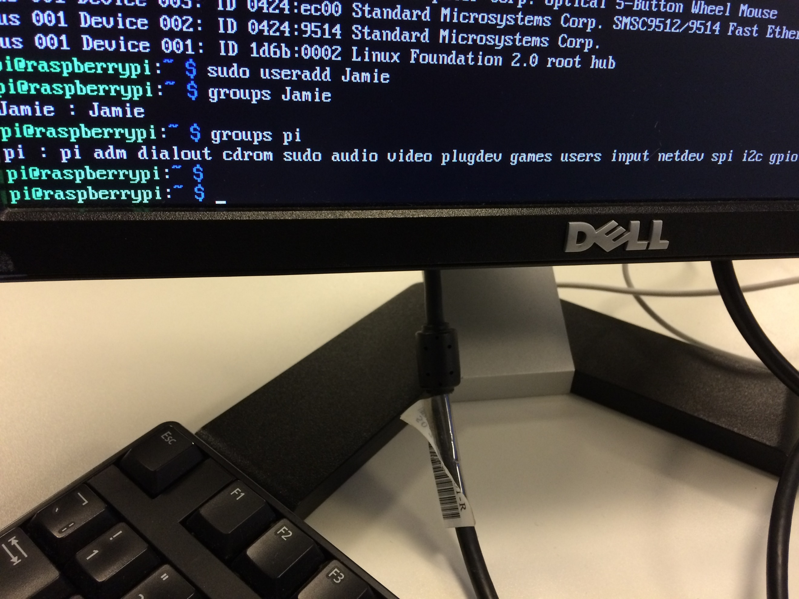



C.

Login as the new user try a sudo operation.

The sudo operation does not work because I have not linked the account to the sudo group. Therefore, wont have permission to do sudo code.

D.

Can you see if your usb is connected and where is it mounted?

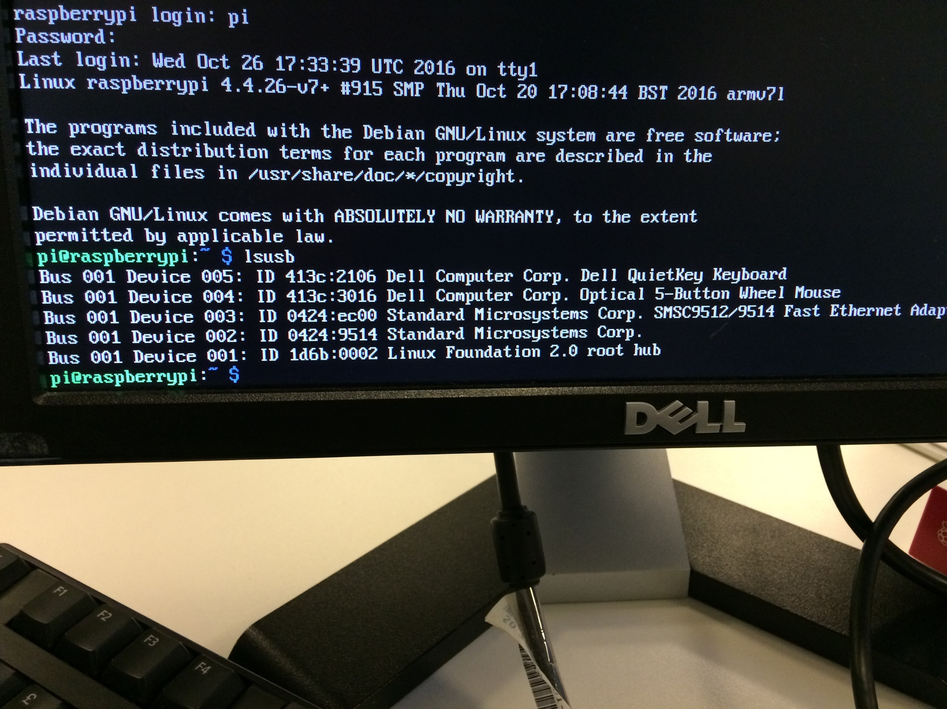

**Task 3**

#### Update your user so that it has sudo privileges. Hint you will need to append the correct group to your user.

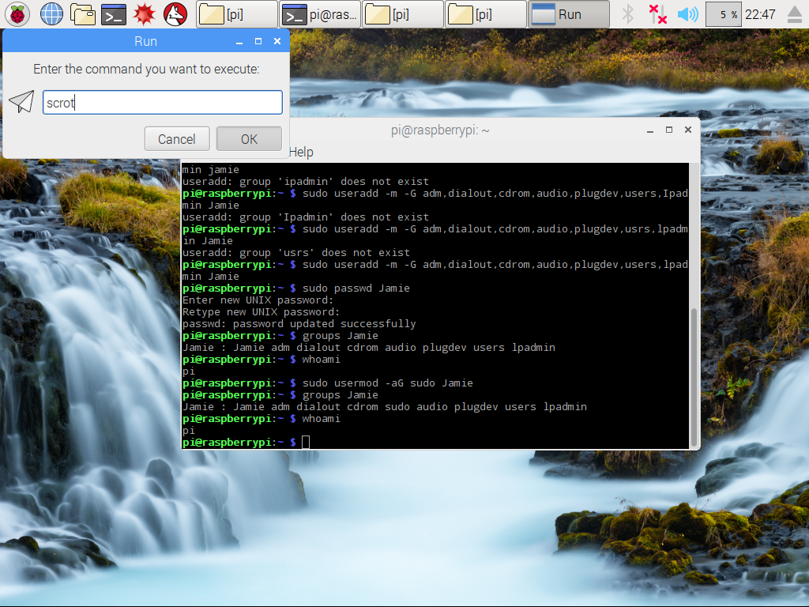

**Task 4**:

go to the root directory and find the inodes of the first 5 sub-directories off the root directory

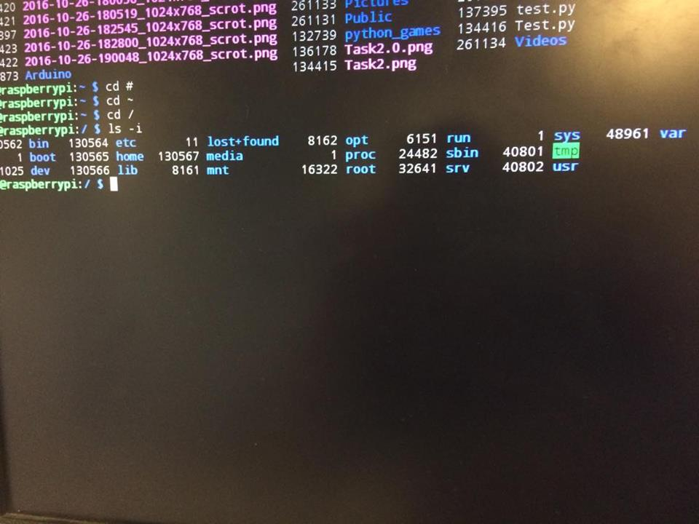

Task 4a:

use stat to find out the details of the /etc/passwd file. Explain what these stats mean

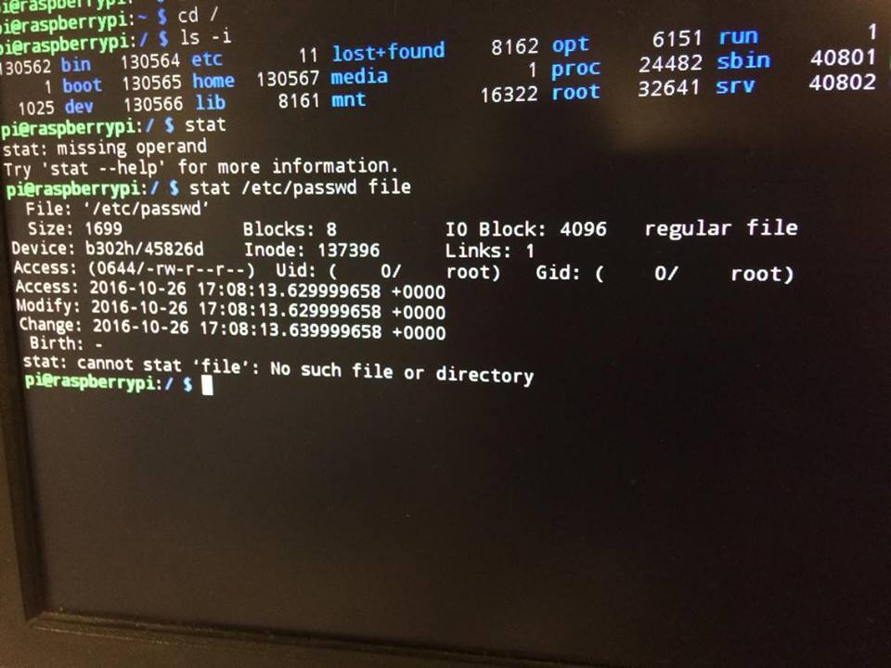

**Task 5:**

use touch to create a new file in your home directory. Then change the timestamp so that the last modified date is 1st October 2014. Check this has worked.

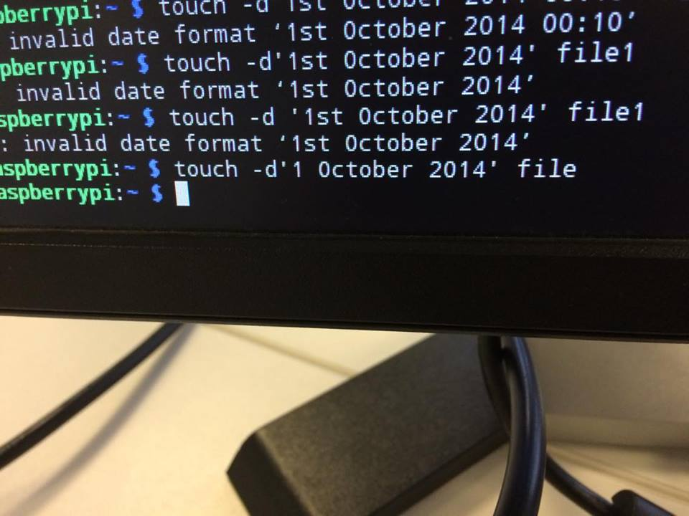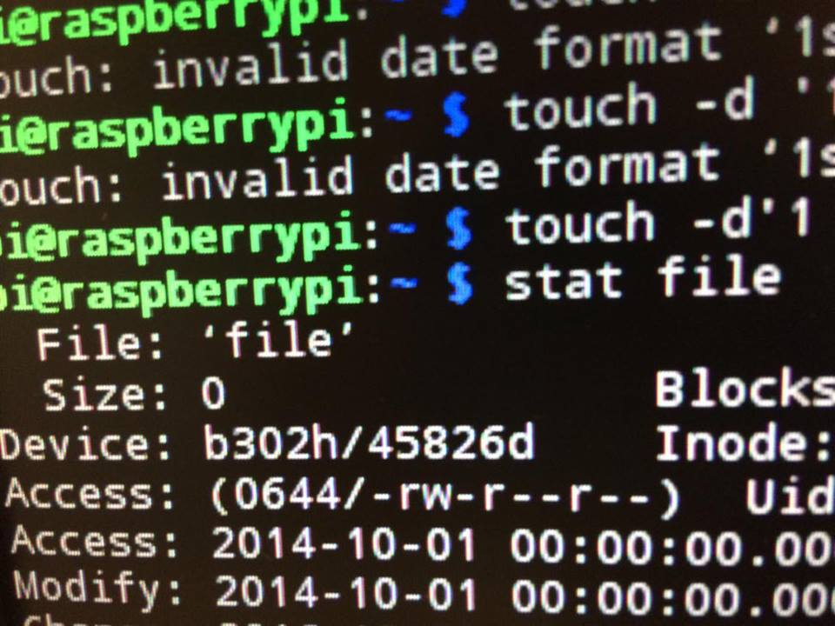

**Task 6**

– Find out which OS VFAT was designed for and which one EXT4 was designed for. What are the main differences between the 2 systems.

OS VFAT is a file system, this is an extension of the FAT file system that was brought in Windows 95. VFAT file system can contain up to 255 characters, spaces, and multiple periods. This is supported by most operating systems for personal computers, including all versions of windows. EXT4 is a file system that was designed for Linux based operating systems and is the 4th extended file system version. It was introduced in 2008 and the main difference between the 2 different file systems is that the EXT4 system can store larger quantities of data, VFAT is much more user friendly and easier to use because of this and finally the VFAT is compatible with nearly all devices while EXT4 is not.

Task 7: Overclock the Raspberry Pi to 900MHZ, record the results and then restore to default

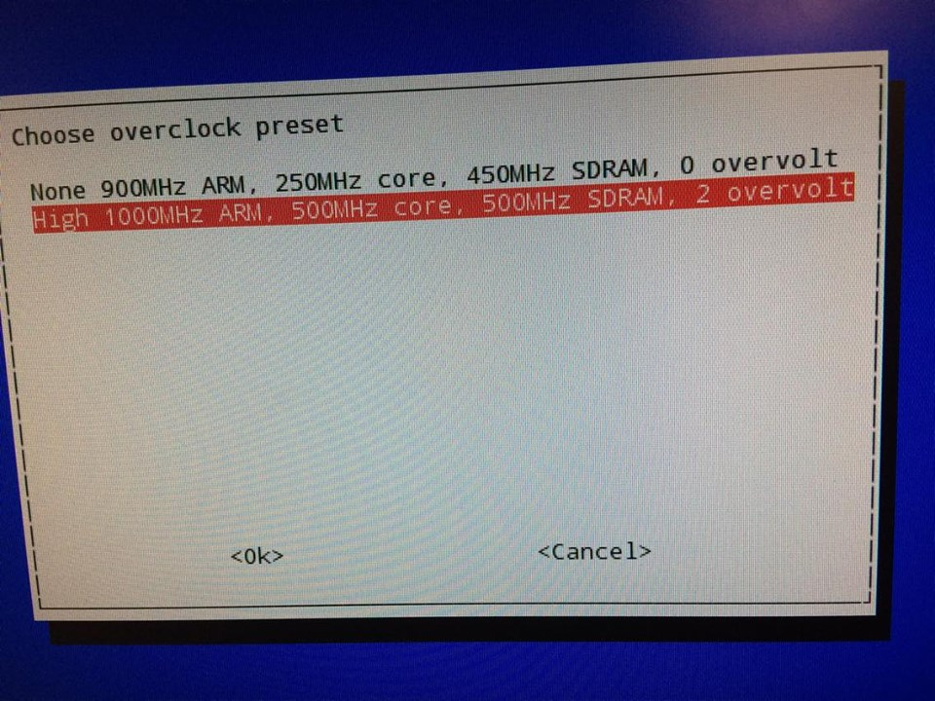

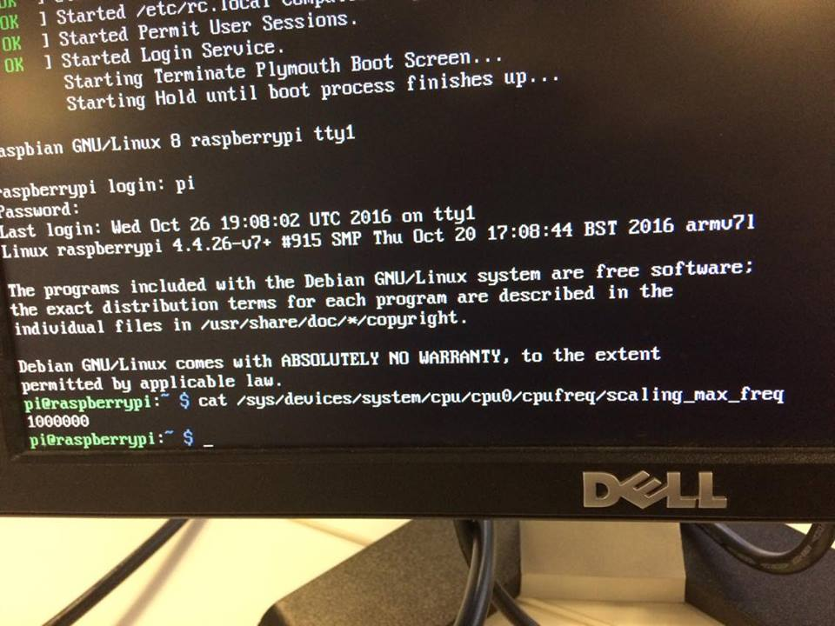

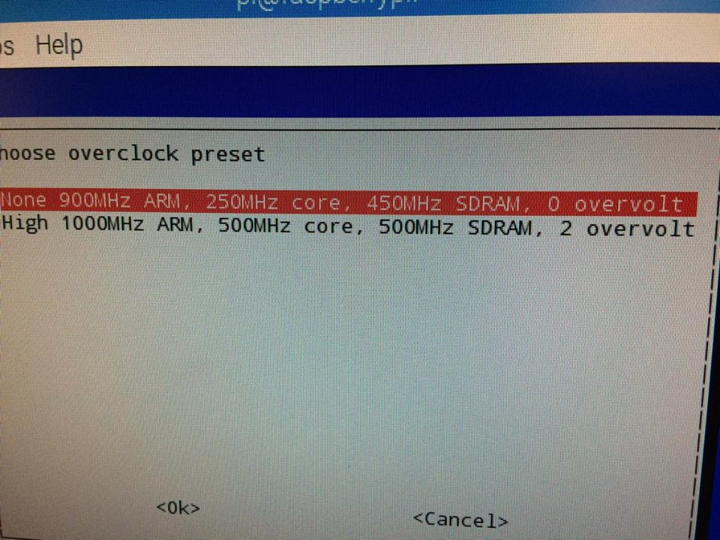

Task 8: Find the memory configuration of your Pi

